Project: | Moffat-Bay
Course: | CSD460-O307 Capstone in Software Developme (2261-DD)
Description: | Test Cases for pages: Register, Login, & Home
Date: | 2025/11/11
To complete the test case plan, fill out the information for Project, Course, Description and Date in the header below.
.
TABLE OF CONTENTS
Home – Landing Page for Viewing 3
Home – Test Navigation 4
Register – New User Registration 6
Register – Duplicate Email Validation 8
Login – Valid Login 10
Login – Invalid Login 11

For each test, the developer should: provide a test description, a test objective, the developer name and date tested. For each step, fill out the actions to be taken and describe the expected results, and indicate yes or no for each step depending upon the result. The peer tester should provide their name, date tested, indicate yes or no for each step depending upon the result, and a screenshot (thumbnail) of the result.

Test 1 | Home – Landing Page for Viewing
 | Test Objective: Test whether page and styling load | Developer: Julio Pochet Edmead  Date tested: 2025/11/4 | Peer tester: Kypton Lantz  Date tested: 2025/11/11
Step | Action | Expected results: | Developer pass/fail | Tester pass/fail  + Screenshot
1 | Navigate to /home.jsp | Input a valid URL for Moffat Bay landing page | Yes | Yes  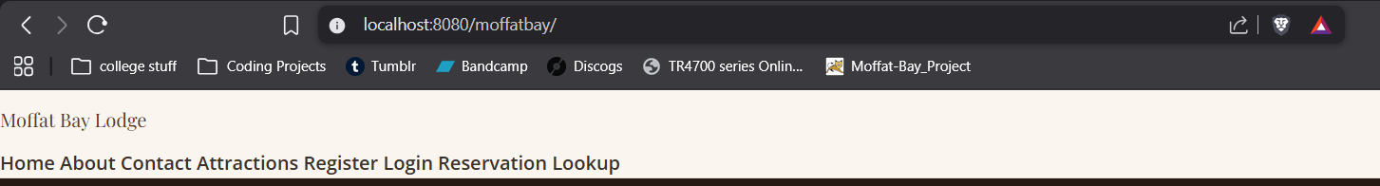
2 | Page loads, no 404 error | Tomcat is running and page links successfully | Yes | Yes  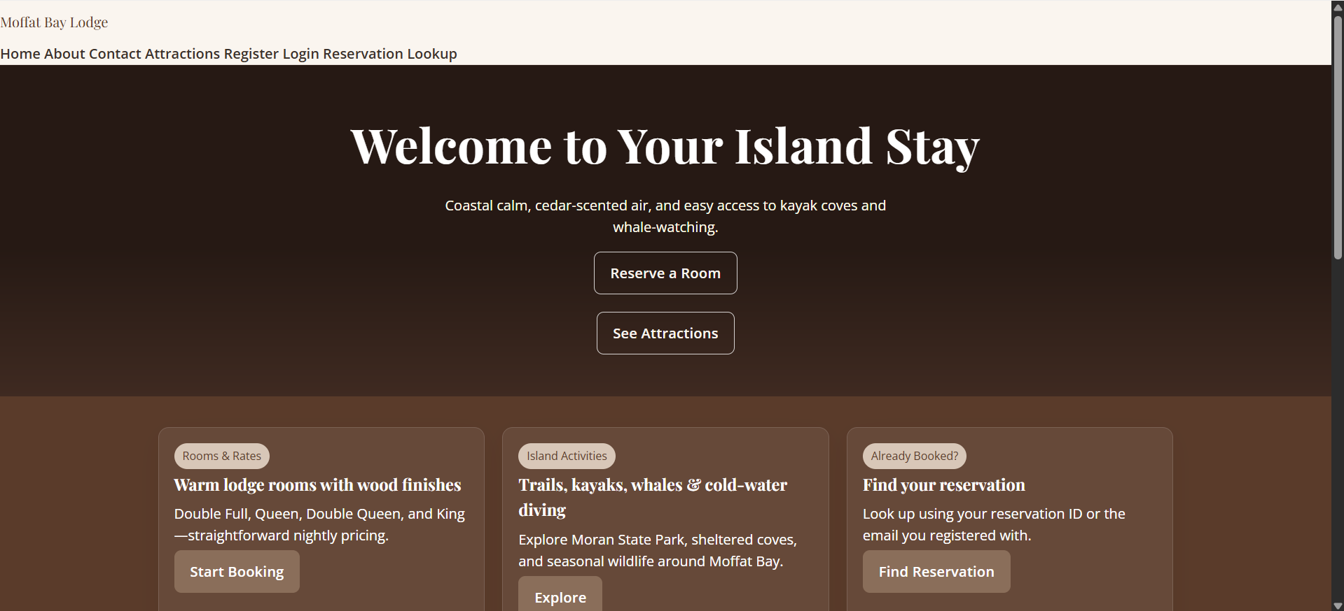
3 | View styling | Stylesheets load appropriately | Yes | Yes (see image above)
Comments | Page loads perfectly. Further styling is required, but otherwise the landing page comes up as it should.

Test 2 | Home – Test Navigation
 | Test Objective: Navigate between several pages to confirm pages link appropriately | Developer: Stella Kemp  Date tested: 2025/11/10 | Peer tester: Kypton Lantz  Date tested: 2025/11/11
Step | Action | Expected results: | Developer pass/fail | Tester pass/fail
1 | Click Reserve a Room text button | Button will direct to the Reservation page | Yes | Yes  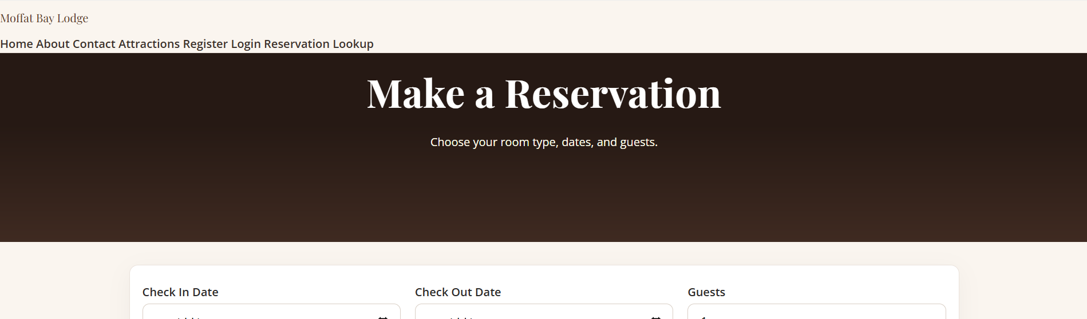
2 | Click See Attractions text button | Button will direct to the Attractions page | Yes | Yes  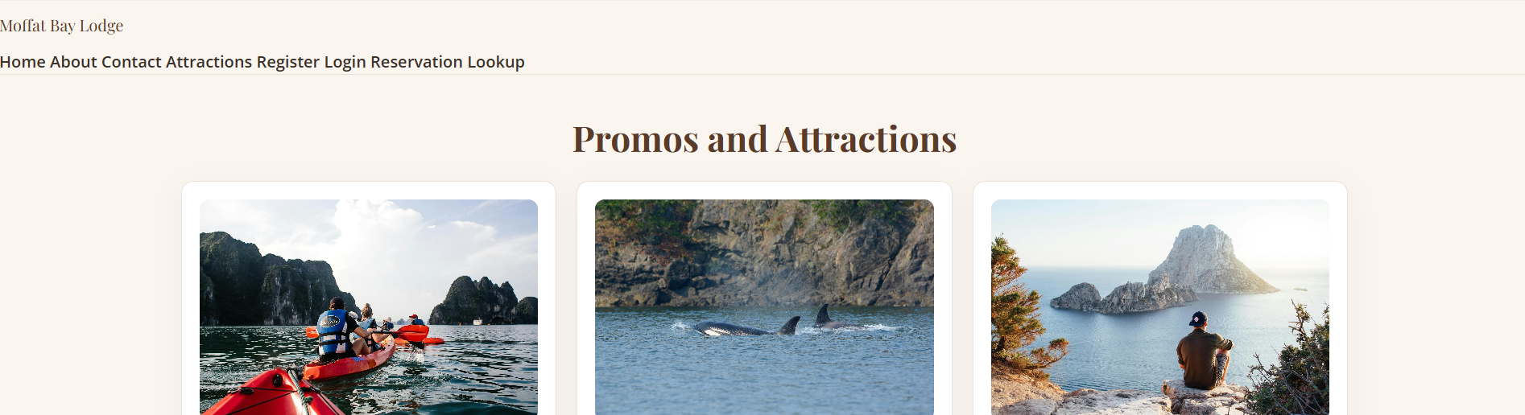
3 | Click Start Booking text button | Button will direct to the Reservation page | Yes | Yes  
4 | Click Explore text button | Button will direct to the Attractions page | Yes | Yes  
5 | Click Find Reservation button | Button will direct to the Lookup page | Yes | Yes  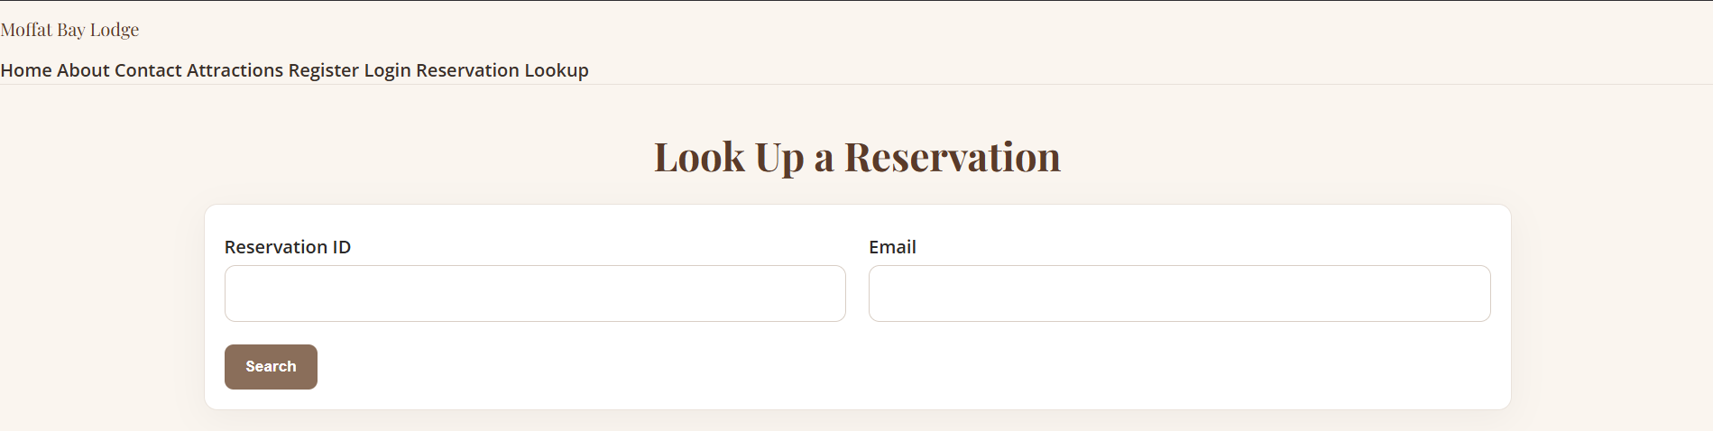
Comments | Each of the links on the Home page led to the expected follow up page. No errors occurred during this process.

Test 3 | Register – New User Registration
 | Test Objective: Test if new user information is recorded, stored, and user is redirected to a confirmation | Developer: Stella Kemp  Date tested: 2025/11/10 | Peer tester: Kypton Lantz  Date tested: 2025/11/11
Step | Action | Expected results: | Developer pass/fail | Tester pass/fail
1 | Navigate to /register.jsp | Registration page loads successfully | Yes | Yes  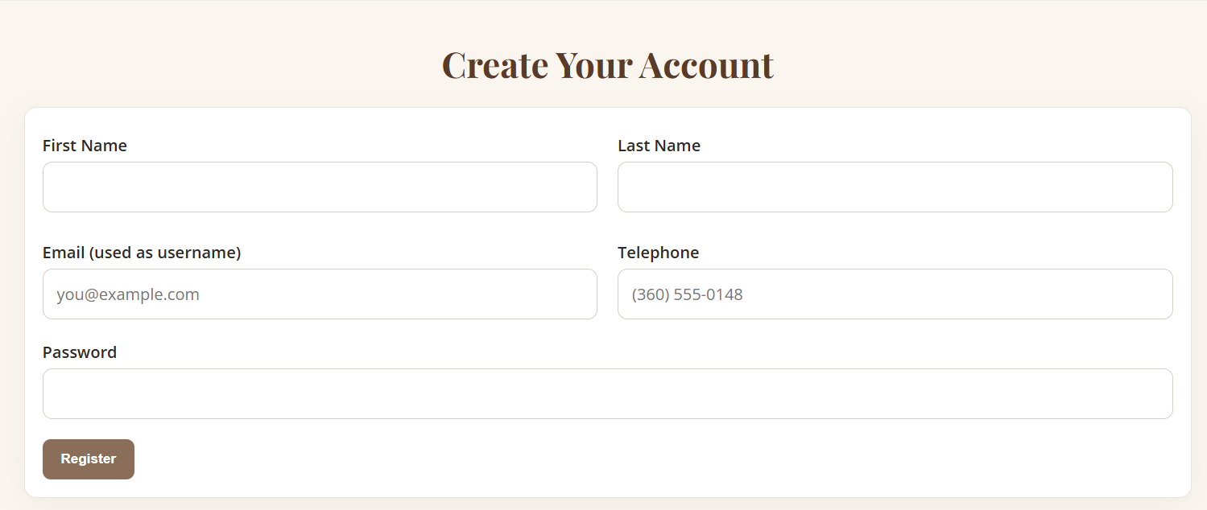
2 | Fill form with valid data | Text fields work and password is hidden | Yes | Yes  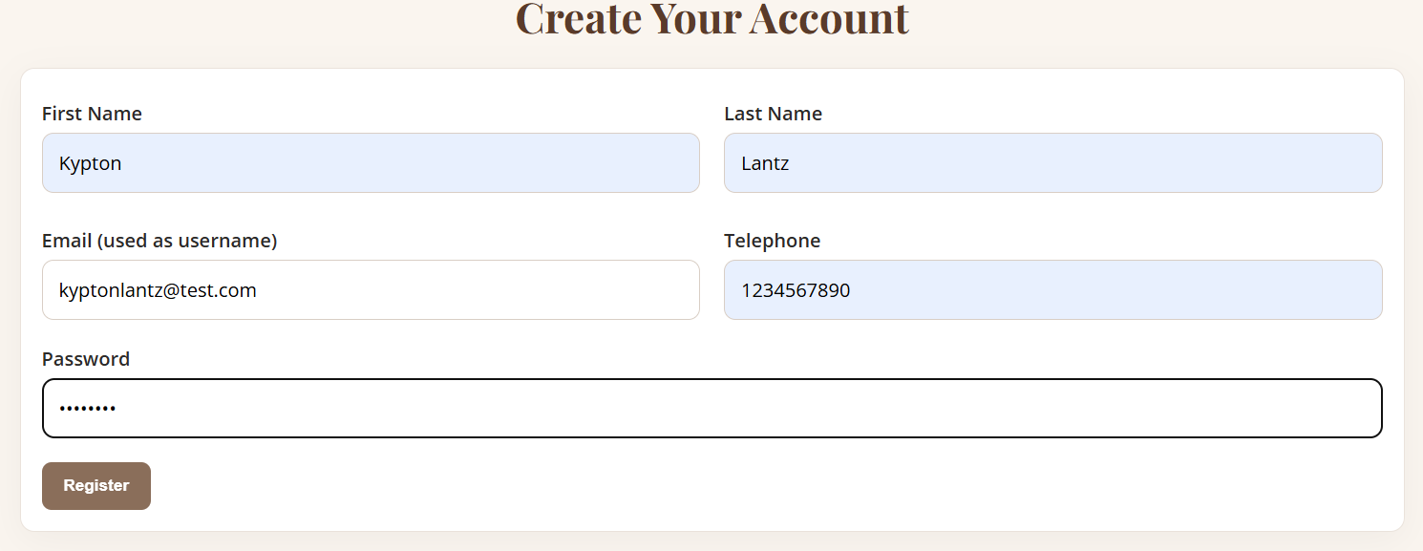
3 | Click Register | User record created in DB and user is redirected to confirmation page | Pending | Yes & No  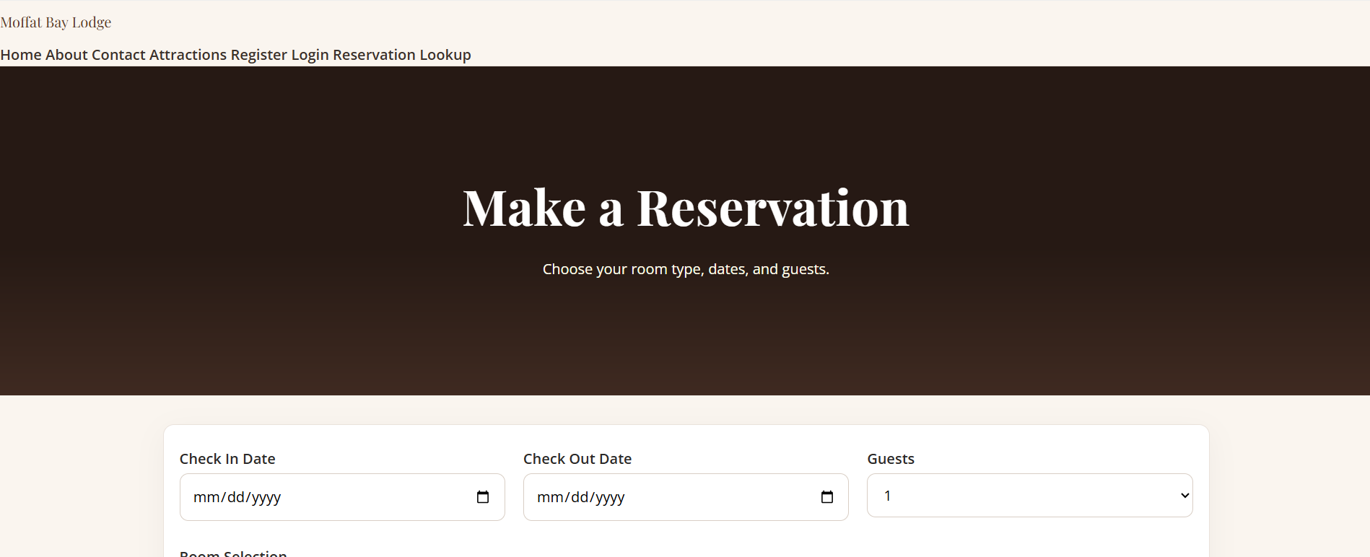  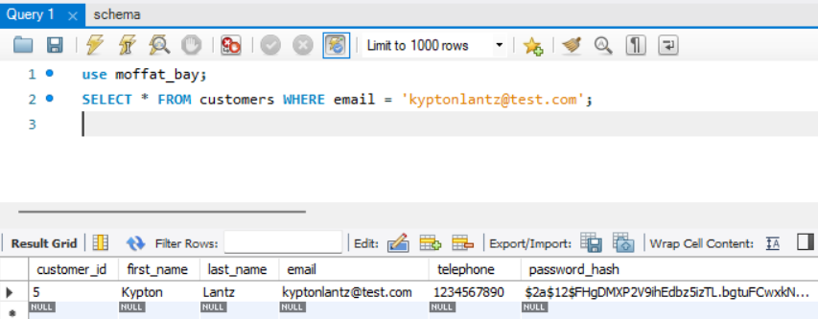
Comments | The user registration worked in terms of the user being stored in the database; however, we will need to work on it redirecting to a confirmation page instead of the reservation page and updating the session UI to show the user is logged in under their account.

Test 4 | Register – Duplicate Email Validation
 | Test Objective: Test that users cannot register again with the same login information | Developer: Stella Kemp  Date tested: 2025/11/10 | Peer tester: Kypton Lantz  Date tested: 2025/11/11
Step | Action | Expected results: | Developer pass/fail | Tester pass/fail
1 | Attempt registration using same email | Text fields work and password is hidden | Yes | Yes  
2 | Submit form | Error message shown; no new record created | Pending | Yes & No    
Comments | The database shows that no new user was created from the same email, but it did not indicate an error to the user and again rerouted to the Reservation page instead of prompting the user to input different information.

Test 5 | Login – Valid Login
 | Test Objective: Login with valid user credentials | Developer: Stella Kemp  Date tested: 2025/11/10 | Peer tester: Kypton Lantz  Date tested: 2025/11/11
Step | Action | Expected results: | Developer pass/fail | Tester pass/fail
1 | Go to /login.jsp | Page loads successfully | Yes | Yes  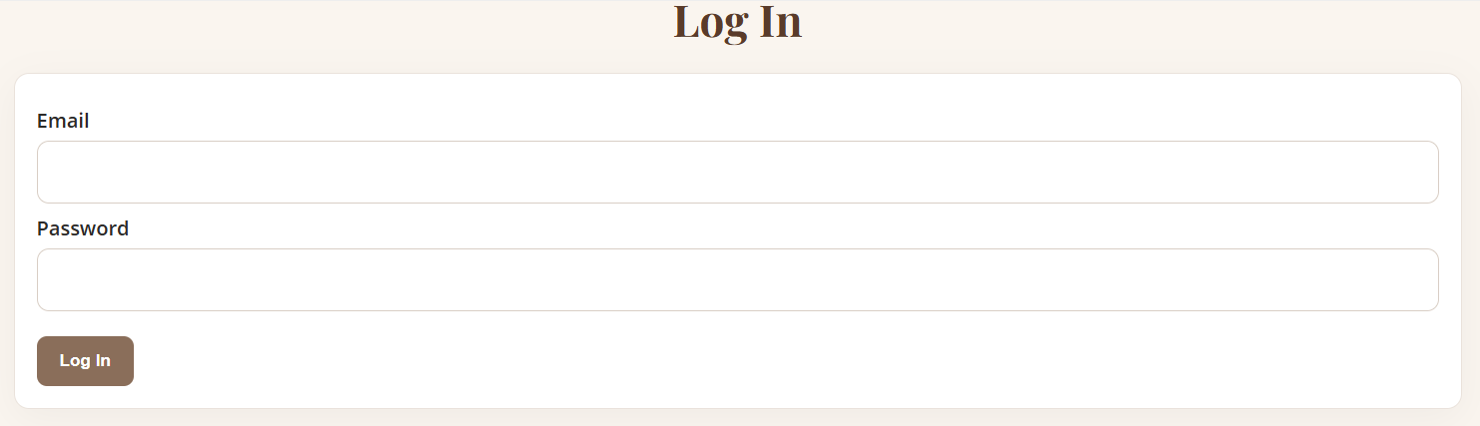
2 | Enter valid credentials | Text fields work and password is hidden | Yes | Yes  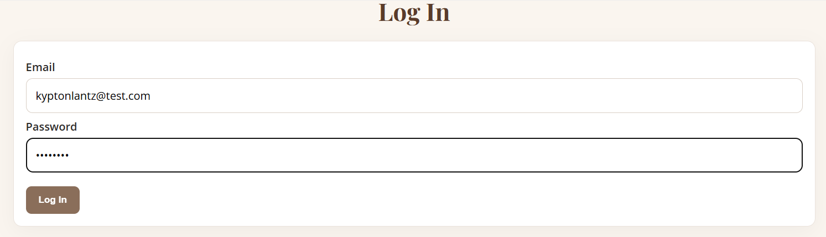
3 | Click Login | Login is successful; redirects to reservation.jsp and session is created | Yes | Yes & No  
Comments | No errors shown. It did redirect to the reservation page, but also there was no indicator that it was successful or show that the user is currently logged in.

Test 6 | Login – Invalid Login
 | Test Objective: Attempt login with invalid credentials, this should not be allowed | Developer: Stella Kemp  Date tested: 2025/11/10 | Peer tester: Kypton Lantz  Date tested: 2025/11/11
Step | Action | Expected results: | Developer pass/fail | Tester pass/fail
1 | Go to /login.jsp | Page loads successfully | Yes | Yes  
2 | Enter wrong email/password | Text fields work and password is hidden | Yes | Yes  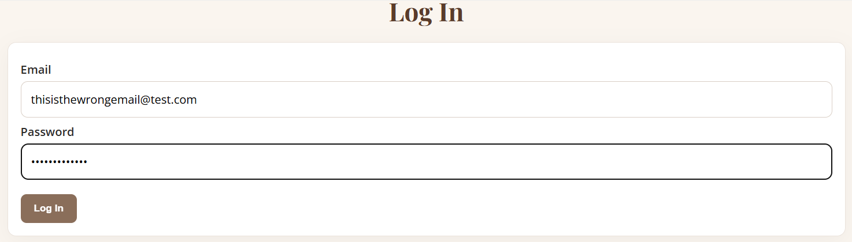
3 | Click Login | Display ‘Invalid email or password’; stays on login page | Yes | Yes  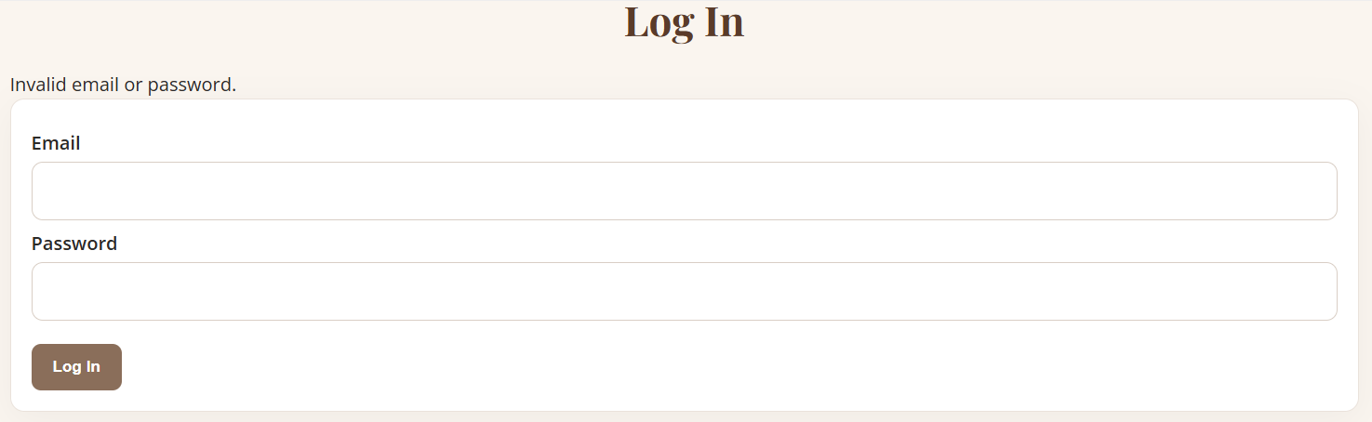
Comments | Given invalid credentials, an error message was displayed and the page stayed on the login.

